Q.1:

#include <iostream>

using namespace std;

float calculator(float a, float b, char c)

{

switch (c)

{

case '+':

return a + b;

case '-':

return a - b;

case '\*':

return a \* b;

case '/':

return a / b;

case '%':

return (int)a % (int)b;

case '^':

int value = 1;

for (int i = 0; i < b; i++)

{

value \*= a;

}

return value;

}

}

int main()

{

float op1, op2;

char option = '+';

cout << "Welcome to the Calculator!\nEnter\n+ for addition operation\n- for subtraction operation\n\* for multiplication operation\n/ for division operation\n% for modulus operation\n^ for exponentiation operation\nq to quit\n";

while (true)

{

cout << "\n-->";

cin >> option;

if (option == 'q' || option == 'Q')

break;

else {

cout << "Enter the first operand: ";

cin >> op1;

cout << "Enter the second operand: ";

cin >> op2;

cout << "\nThe result is " << calculator(op1, op2, option) << endl;

}

}

system("pause");

return 0;

}

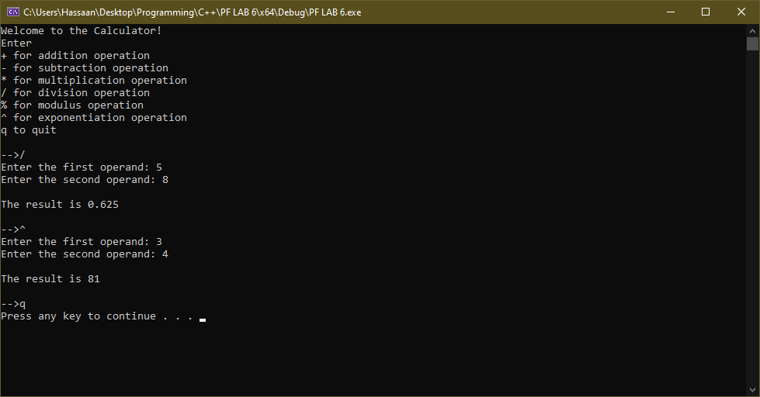

Q.2:

#include <iostream>

using namespace std;

bool isPalindrome(int N)

{

int orig = N, reverse = 0, digit;

while (N > 0) {

digit = N % 10;

reverse = reverse \* 10 + digit;

N /= 10;

}

return (orig == reverse);

}

int main()

{

int number;

cout << "Enter a number: ";

cin >> number;

if (isPalindrome(number))

cout << "It is a palindrome." << endl;

else

std::cout << "It is not a palindrome." << endl;

system("pause");

return 0;

}

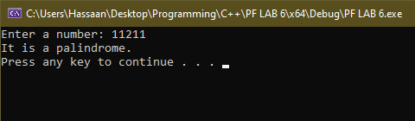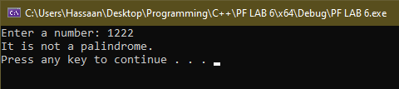

Q.3:

#include <iostream>

#define pi 3.14159;

using namespace std;

double area(double radius)

{

return radius\*radius\*pi;

}

int main()

{

double r;

cout << "Enter radius of circle: ";

cin >> r;

cout << "Area of circle is: " << area(r) << endl;

system("pause");

return 0;

}

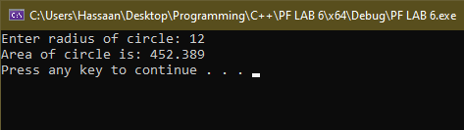

Q.4:

#include <iostream>

using namespace std;

double CalculateGPA(char g1, int c1, char g2, int c2, char g3, int c3, char g4, int c4, char g5, int c5)

{

double gpa = 0;

switch (g1)

{

case 'A':

gpa += 4 \* c1;

break;

case 'B':

gpa += 3 \* c1;

break;

case 'C':

gpa += 2 \* c1;

break;

case 'D':

gpa += 1 \* c1;

break;

case 'F':

gpa += 0;

break;

}

switch (g2)

{

case 'A':

gpa += 4 \* c2;

break;

case 'B':

gpa += 3 \* c2;

break;

case 'C':

gpa += 2 \* c2;

break;

case 'D':

gpa += 1 \* c2;

break;

case 'F':

gpa += 0;

break;

}

switch (g3)

{

case 'A':

gpa += 4 \* c3;

break;

case 'B':

gpa += 3 \* c3;

break;

case 'C':

gpa += 2 \* c3;

break;

case 'D':

gpa += 1 \* c3;

break;

case 'F':

gpa += 0;

break;

}

switch (g4)

{

case 'A':

gpa += 4 \* c4;

break;

case 'B':

gpa += 3 \* c4;

break;

case 'C':

gpa += 2 \* c4;

break;

case 'D':

gpa += 1 \* c4;

break;

case 'F':

gpa += 0;

break;

}

switch (g5)

{

case 'A':

gpa += 4 \* c5;

break;

case 'B':

gpa += 3 \* c5;

break;

case 'C':

gpa += 2 \* c5;

break;

case 'D':

gpa += 1 \* c5;

break;

case 'F':

gpa += 0;

break;

}

gpa /= c1 + c2 + c3 + c4 + c5;

return gpa;

}

int main()

{

double GPA = CalculateGPA('A', 3, 'B', 3, 'B', 3, 'C', 2, 'A', 1);

cout << "My gpa is: " << GPA << endl;

system("pause");

return 0;

}

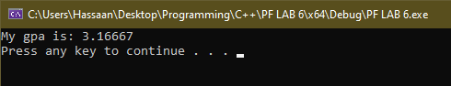

Q.5:

#include <iostream>

using namespace std;

void FindMinMax(int& minValue, int& maxValue) { // Passing two values by reference.

int input;

bool firstInput = true;

cout << "Enter integers (enter -1 to stop):\n";

while (true) {

cin >> input;

if (input == -1) {

if (firstInput) {

cout << "No valid input provided." << endl;

return;

}

break;

}

if (firstInput) {

minValue = maxValue = input;

firstInput = false;

}

else {

if (input < minValue) {

minValue = input;

}

if (input > maxValue) {

maxValue = input;

}

}

}

}

int main()

{

int min{ 0 }, max{ 0 };

FindMinMax(min, max);

cout << "Minimum is " << min << " and maximum is " << max << endl;

system("pause");

return 0;

}

